APPLIED DATA SCIENCE 1 ASSIGNMENT (VISUALISATION)

STUDENT DETAILS: -

NAME: - BOINA SYAM SUNDAR

STUDENT ID: - 21061898

SUBMISSION DATE: - 12-11-2022

DATA SET

THE DATA SET IS ABOUT THE POPULATION OF ALL COUNTRIES FOR YEARS 2000 – 2015. IN THAT I HAVE TAKEN ONLY THE TOTAL POPULATION OF ALL COUNTRIES IN THE YEARS OF 2010 -2015.

DATASET LINK: - <https://databank.worldbank.org/indicator/NY.GDP.MKTP.KD.ZG/1ff4a498/Popular-Indicators>

PYTHON CODE GIT LINK: -

IN THIS CODE I HAVE ASKED THE GIVEN THE USER AN OPTION FOR HOW MANY AND WHAT ARE THE COUNTRIES (COUNRTY CODES) HE/SHE WANTED TO COMPARE USING DIFFERENT PLOTS. I HAVE USED LINE GRAPH, BAR GRAPH, PIE GRAPH. FOR SHOWING THE RESULTS OF THE CODE TEST I HAVE TAKEN 5 COUNTRIES FOR COMARING AND THEY ARE IND, CHN, USA, PAK, IDK.

LINE GRAPH:

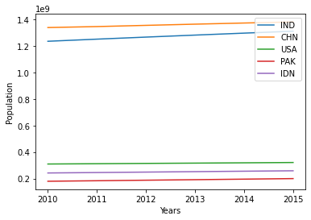

IN THE LINE GRAPH WE CAN SEE HOW A VARIABLE IS INCREASING/DECREASING IN Y-AXIS FOR DIFFERENT VALUES IN X-AXIS.

I HAVE TAKEN THE LINE GRAPH BECAUSE WE CAN SEE HOW A COUNTRY POPULATION IS INCREASING / DECREAING OVER THE YEARS FROM 2010-2015. SO, IN LINE GRAPH IF THE SLOPE IS POSITIVE, IT IS AN INCREAING GRAPH AND IF THE SLOPE IS NEGATIVE THEN IT IS A DECREAING GRAPH AND IF THE SLOPE IS 0 THEN IT IS A CONSTANT GRAPH. SO, FROM THE ABOVE GRAPH WE CAN SEE THAT INDIA IS HAVING LARGER SLOPE COMPARED TO OTHER COUNTRIES SO IT’S POPULATION IS INCREASING MORE WHEN COMPARED TO OTHER COUNTRIES AND THE HIGHEST POPULTED COUNTRY IN THE GIVEN COUNTRIES IS CHINA.

BAR GRAPH: -

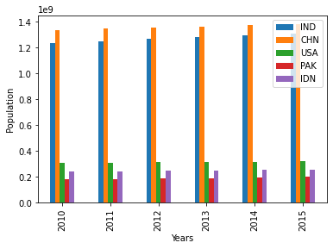

IN THE BAR GRAPH THE HEIGHT OF RECTANGULAR BAR REPRESENTS (Y-AXIS VALUE) THE VALUE OR FREQUENCY OF X-AXIS VARIABLE.

I HAVE TAKNE THE BAR GRAPH BECAUSE ONE CAN COMPARE FOR A PARTICULAR YEAR WHAT IS THE TOATAL POPULATION OF THE SELECTED COUNTRIES. SO, FROM THE ABOVE GRAPH WE CAN SEE IN 2010 THE POPULATION OF ALL THE SELECTED COUNTRIES AND FOR OTHER YEAR YEARS ALSO.

PIE GRAPH:

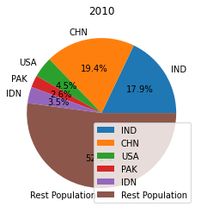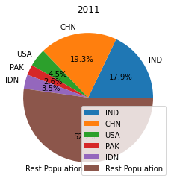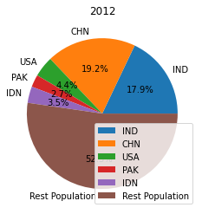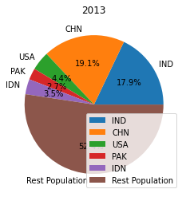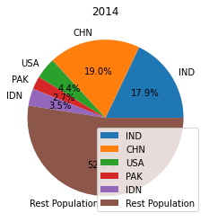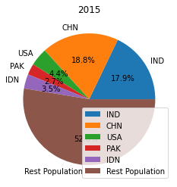

IN THE PIE GRAPH THE TOTAL CIRCLE DIVIDED INTO SLICES EACH SLICE REPRESENTS A DATA AND THAT PORTION OF SLICE REPRESENTS THE PROPORTIONAL TO THE QUANTITY IT REPRESENTS.

SO, I HAVE TAKEN THE PIE GRAPH TO REPRESENT TO WHAT PORTION OF WORLD’S POPULATION EACH SELECTED COUNTRIES POPULATION HAVING. AND I HAVE PRODUCED PIE CHARTS FOR THE YEARS 2010-2015. SO, WE CAN SEE WHAT PORTION OF A SPECIFIC COUNTRIES POPULATION TO THE WORLD’S POPULATION. SO, FROM THE ABOVE PIE GRAPHS WE CAN SEE THAT INDIA IS HAVING ALMOST 17.9% TO WORLD’S POPULATION AND THE CHINA’S POPULATION IN 2010 IS 19.4% AND IN 2015 IT IS 18.8% OF TOATAL POPULATION.